- HARDWARE COMPONENTS
Q1. Draw a labelled diagram of a desktop PC, clearly marking the motherboard, CPU, RAM, GPU, and both HDD and SSD storage components
ANS.

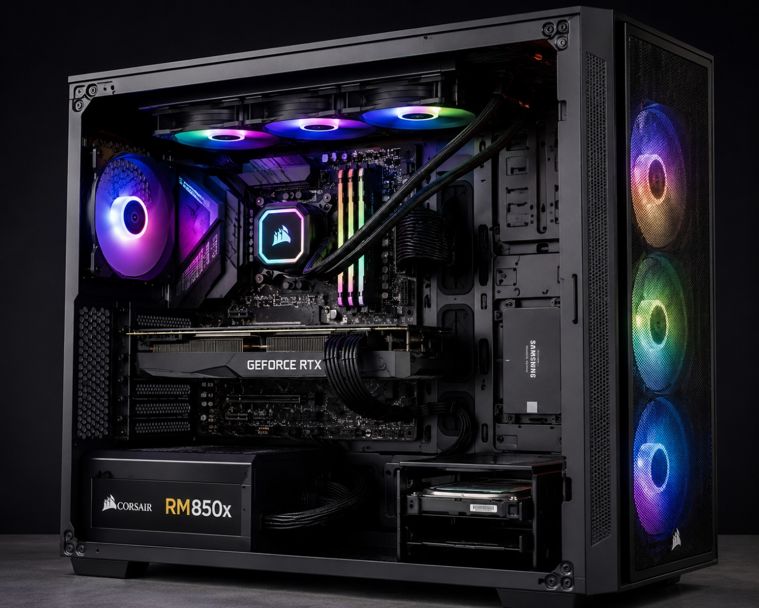
CPU (CENTRE PROSSING UNIT) UNDER COOLING SYSTEM
CASE FAN
MOTHERBOARD
PC CABINATE (TOWER)
SSD (SOLID STATE DRIVE
GPU (GRAPHICS CARD)
RAM
HDD (HARD DISK DRIVE)
POWER SUPPLY UNIT (PSU)

Q2. Create a comparison table showing the main differences between HDD and SSD storage in terms of speed, durability, and typical use cases.<br><br><em><strong>Hint:</strong> Think about which one is faster, which is more shock-resistant, and where you would usually find each type (laptop, gaming PC, etc.).</em>

ANS - DIFFERENCE BETWEEN HDD AND SDD
FEATURES | HDD(HARD DISK DRIVE) | SSD (SOLID STATE DRIVE)
Technology | Mechanical (spinning magnetic platters) | Flash memory (stationary microchips)
Speed | Slower (typically 50 to 160 MB/s) | Significantly faster (500 MB/s to 7000+ MB/s)
Durability | Vulnerable to Physical shock. Dropping a laptop with an HDD can easily permanently damage the drive. | Highly durable and shock-resistant because it has no moving parts and can easily survive bumps and drops that would destroy an HDD
Typical Use Cases | Mass Storage & Budget Systems: Best for storing enormous files cheaply, such as large family photo/video archives, server storage, budget desktop PCs, or external backup drives | Laptops & High Performance: The standard for modern laptops (to save battery and prevent drop damage), gaming PCs, and as the primary "boot drive" to hold the operating system.

Summary: The SSD is faster than the HDD because it does not have any moving parts in it like the HDD have and also the SSD is more shock- resistant than the HDD is more vulnerable to physical shock due to drops and bumps.
- HDD is commonly found in desktop PCs, older laptops, and backup storage.
- SDD is commonly found in modern laptops ,gamming PCs, and high-performance Desktops.

Q3. Write a short explanation (2-3 sentences each) describing the role of the CPU, RAM, and GPU in running a game like PUBG or Free Fire on a PC.
ANS.
- CPU (Central Processing Unit):
The CPU is the brain of the computer. It processes all the instructions and controls how the game works. It also handles player actions, enemy movements, and other game tasks. A faster CPU helps the game run smoothly and reduces delays.

- RAM (Random Access Memory):
RAM stores the game data while you are playing. It helps the computer quickly access the information needed by the game. More RAM allows the game to load faster and run with less lag.

- GPU (Graphics Processing Unit):
The GPU is responsible for displaying the game's graphics on the screen. It creates the characters, maps, and special effects you see while playing. A powerful GPU gives smoother gameplay, higher frame rates, and better picture quality.

Q4. Imagine you want to upgrade your PC to run the latest version of FIFA smoothly. List which hardware components you would consider upgrading and explain why for each.
ANS – First I will check the minimum system requirements to run the latest version of FIFA smoothly. These are the minimum requirements to run the FIFA smoothly
Operating System: Windows 10/11 (64-bit)
Processor (CPU): Intel Core i5-6600K or AMD Ryzen 5 1600
Memory (RAM): 8 GB
Graphics Card (GPU): NVIDIA GTX 1050 Ti or AMD Radeon RX 570 (4 GB VRAM)
DirectX: Version 12
Storage: 100 GB free space

Now I will get the required components according to the compatibility to run FIFA smoothly in my Desktop PC.

